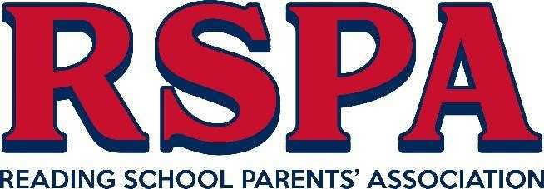

Dear Parents and Carers,
We would like to take this opportunity to warmly welcome you and your child to the Reading School family. The RSPA is an active and vibrant part of Reading School and we are looking forward to welcoming and assisting you every step of the way, even before your child officially joins the School in September.
The RSPA feels that one of its most vital roles is supporting the families of the children and in particular those of the new Year 7s.

Classlist – RSPA Online Membership Portal
As an RSPA member you will have access to our parent communication portal, Classlist. Here, you will be able to immediately start to communicate with other members in your child’s class. We will also use this route to keep you updated.

How to join the RSPA
We would love you to join us. There is no commitment to be involved in anything unless you would like.
Please find our online membership form at: https://www.readingschoolpa.org.uk/membership-application.
Also go through our RSPA Handbook 2023 and any questions regarding membership can be directed to: memsec@readingschoolparents.co.uk

Facebook
Here’s our Main Facebook page Reading School Parents Association. We also administrate individual pages for all the year groups and yours can be found at 2023 Entry Parents and Carers of Reading School. Please answer all the membership questions before submitting your request to join.

Website
For lots of great information about how we support the school and ways you can assist, the place to go is our wonderful website at www.readingschoolparents.co.uk

Twitter - @rspareading Instagram - readingschoolparents

Summer Fayre – Sunday 9th July

You are invited to our Summer Fayre on Sunday 9th July (12 – 3) and we would love you to come with your new Year 7s! There will be games, food, drink, inflatables and much more. This is a wonderful opportunity to meet new Year 7 families, meet the RSPA and have some fun!

Virtual Meeting
We would like to welcome every one of you to attend a “Virtual Meeting” on either Monday 19th June or Tuesday 20th June 6.30 – 8.00pm using the link below. This will be an opportunity for us welcome you to the RSPA family and to support you as parents with any queries you may have around starting at the school.

Virtual Meeting Link – 19th June

Virtual Meeting Link – 20th June

Kind regards
The RSPA Team
memsec@readingschoolparents.co.uk

